Introduction
Cisco Packet Tracer is a network simulation application developed by Cisco Systems. It allows learners and professionals to design, configure, and test network topologies in a virtual environment, supporting educational programs and certification preparation.

Objective
The objective of this lab is to present a clear, reproducible procedure for downloading, installing, and validating Cisco Packet Tracer for network simulation activities.

System Requirements
Ensure the computer meets the following minimum specifications before installation:
- Operating System: Windows 10 or Windows 11, macOS, or Linux
• Processor: Dual core or higher cores Processor
• Memory: Minimum 4 GB RAM
• Storage: At least 1 GB of free disk space
• Internet Connection: Stable internet Connection is Required for download and activation

Steps and Procedure
Each step below includes a formal title, a concise description, and the corresponding image. Text and image are kept together as one unit to avoid separation across pages.

Website Link for Installing the Cisco Packet Tracer Software
Cisco Packet Tracer can be downloaded directly from the official Cisco Networking Academy (NetAcad) website. To access it, users must visit https://www.netacad.com/articles/news/download-cisco-packet-tracer , create a free account with the email address and password then the download link becomes available for various operating systems such as Windows, macOS, and Linux. It is important to always download the software from Cisco’s official website to ensure safety, authenticity, and the latest version.
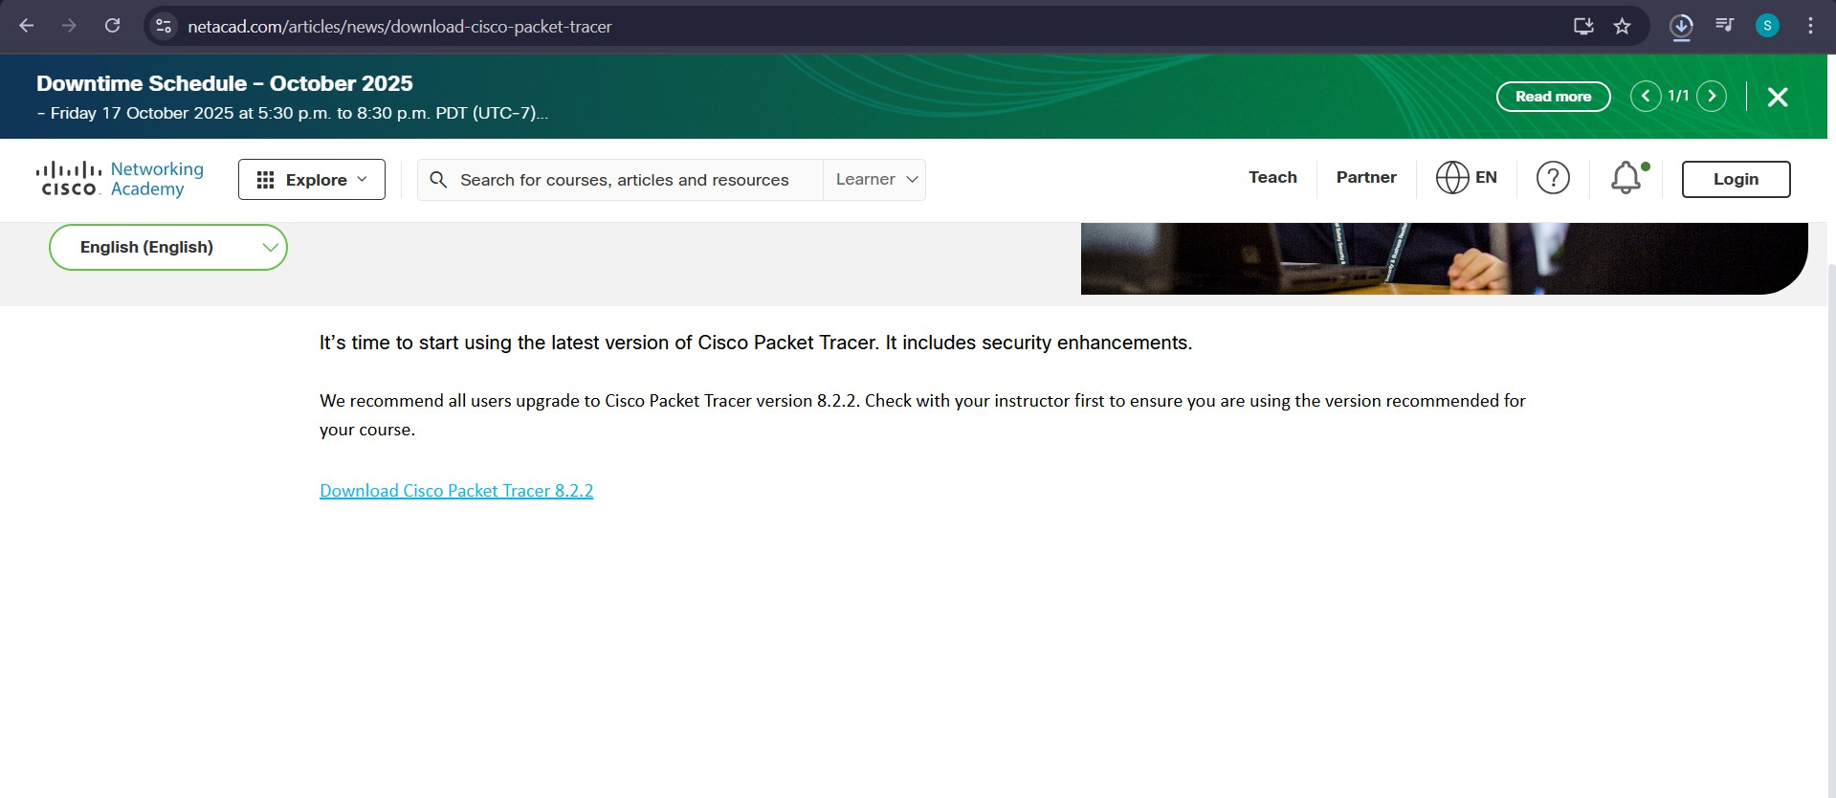
Figure 1.1: Opening webwsite to Download

Selecting OS Version and watching the simple Steps to Install the Cisco Packet Tracer Software from the Website
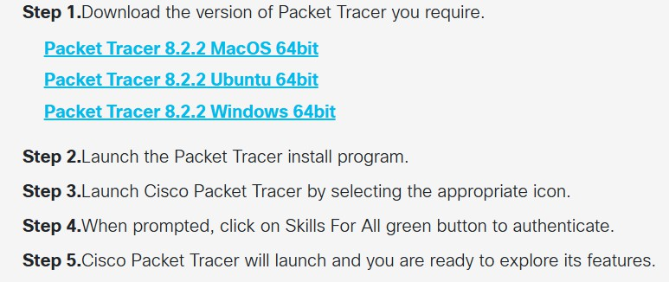
After visiting the Cisco Networking Academy website: Log in or sign up for a Cisco NetAcad account. Go to the Resources or Download section. Locate Cisco Packet Tracer and choose the version suitable for your operating system. Click on the download link and save the installation file (e.g., PacketTracer_Setup.exe) to your computer. Once the file is downloaded, double-click it to start the installation process. Following these steps ensures that the installation begins properly and from a legitimate source.
Figure: 02

Accepting the License Agreement to Install the Cisco Packet Tracer Software
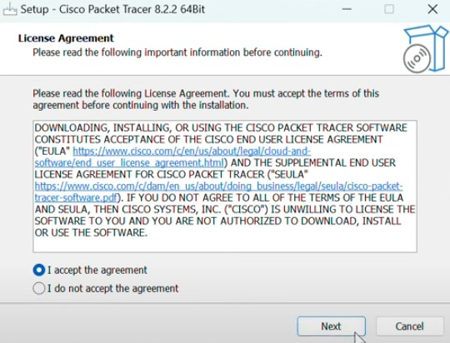
After launching the installer, a License Agreement window appears. This agreement outlines Cisco’s terms and conditions for using the software. The user must carefully read through the agreement before proceeding. To continue with the installation, the user must select “I accept the agreement” and then click Next. Accepting this license ensures that the user agrees to comply with Cisco’s legal terms regarding the software’s usage, distribution, and updates.
Figure: 03

Selecting Destination Location to Install the Cisco Packet Tracer Software
In this step, the installer prompts the user to choose a folder or drive where Cisco Packet Tracer will be installed. By default, it suggests a directory like C:\Program Files\Cisco Packet Tracer.
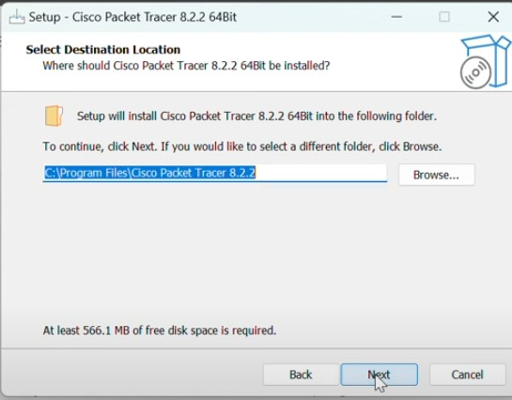
Users can either accept this default location or browse to select a different one. It is recommended to install the software in the default directory unless the system has specific storage or permission restrictions.
Figure: 04

Selecting Additional Tasks to Install the Cisco Packet Tracer Software
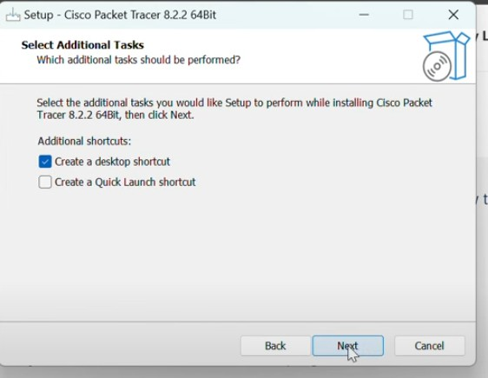
Next, the installer provides an option to select additional tasks, such as creating desktop shortcuts or quick launch icons. These tasks make it easier to access the application after installation. Users can check or uncheck the boxes according to their preferences. Choosing to create a desktop icon is usually recommended for quick access.
Figure: 05

Ready to Install the Cisco Packet Tracer Software
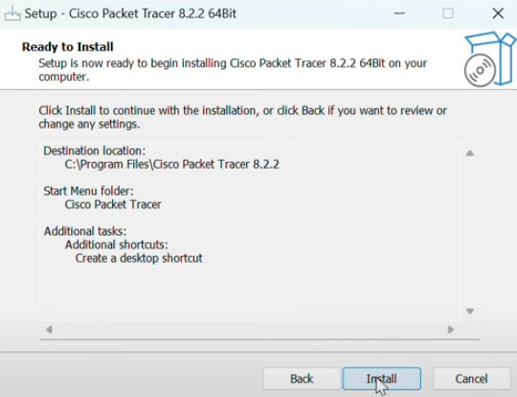
Before the actual installation begins, a summary window appears, showing all the chosen settings such as the destination folder and additional tasks. This screen gives the user a final chance to review and confirm the installation preferences. Once the settings are verified, the user clicks on the “Install” button to proceed. This ensures that the installation starts with the correct configuration.
Figure: 06

Installing the Cisco Packet Tracer Software
At this stage, the installation process begins. The system automatically copies the necessary files, extracts data, and sets up the program in the chosen directory. A progress bar is displayed, indicating the installation status. The process may take a few minutes depending on system performance. Users should wait until the progress bar completes and avoid interrupting the installation.
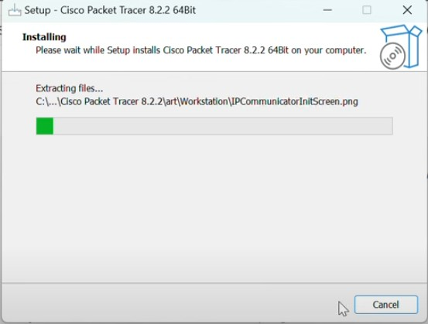
Figure: 07

Finishing Installation of the Cisco Packet Tracer Software
After the installation is successfully completed, a final screen appears with the option to launch Cisco Packet Tracer immediately or close the installer. Clicking Finish completes the setup process. Once installed, users can open Cisco Packet Tracer from the desktop shortcut or Start menu. It is recommended to log in with the Cisco NetAcad account during the first launch to activate the software and access full features.
Figure: 07
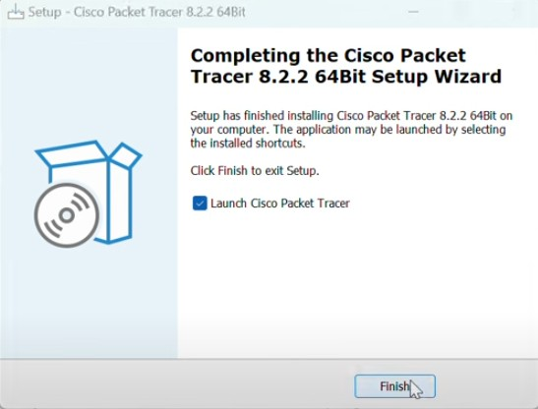

Practical Hands on Verification
After installation, a verification test was performed by connecting two computers through a switch, assigning IP addresses, and using ping to confirm end to end connectivity. Successful replies verified correct operation of Cisco Packet Tracer.

Conclusion
The documented sequence establishes a clear, replicable process for installing Cisco Packet Tracer. The consolidated format ensures titles, descriptions, and images remain together without page breaks or residual blank areas.

